SPH3U **Series and Parallel Circuit Simulation** Name:______________

**Circuit Simulation: Open Explorer or Safari and go the following Circuit Simulation Website**

<https://phet.colorado.edu/en/simulation/legacy/circuit-construction-kit-dc>

**To run the simulation you need to load Java on your laptop or computer. This is available as a free download.**

**Hints on using the simulator**:

*Drag each item from the menu bar on the right to begin constructing your circuit.*

*To break the circuit and add a new component, right click on a junction point and choose “Split Junction”*

*To run the circuit click on the play/pause button (*> *||)*

**Series Circuit analysis:**

Build the following series circuits with 2 batteries, 1, 2 or 3 bulbs and an ammeter as shown.

Close the switch and observe what happens.

Measure the voltage and current in each circuit and draw the circuit using proper symbols.

**Circuit 1: Circuit 2: Circuit 3:**

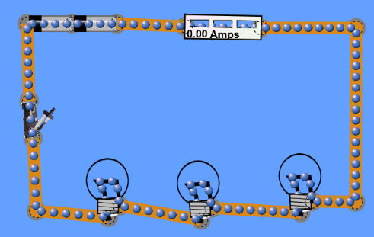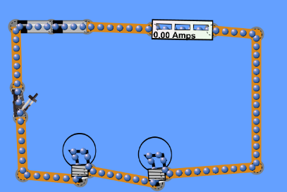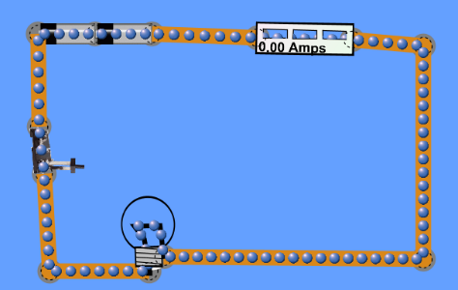

**Diagram:**

Click on the voltmeter tool and measure the voltages across each of the devices in the chart below. If there is an X in the chart, that means you can’t measure that parameter.

**Table 1:Series Circuit Analysis**

|  |  |  |  |  |  |  |
| --- | --- | --- | --- | --- | --- | --- |
| Circuit | Current in Circuit (A) | Voltage  Across  Switch (V) | Voltage  Across  Batteries  (V) | Voltage  Across  Bulb 1  (V) | Voltage across Bulb 2  (V) | Voltage across Bulb 3  (V) |
| 1. bulb |  |  |  |  | X | X |
| 1. Bulbs |  |  |  |  |  | X |
| 1. Bulbs |  |  |  |  |  |  |

1. What happens when you close the switch for circuit 1?
2. How did the brightness of the bulbs in circuits 2 and 3 compare with the bulb brightness in circuit 1?
3. The light bulbs in each circuit are the loads. Find the total load voltage in each case and compare the total load voltage with the source voltage (the battery voltage). :

|  |  |  |
| --- | --- | --- |
| Circuit | Source Voltage (Battery Voltage) V | Total load voltage (V)  *Show the voltages you add up |
| 1 |  |  |
| 2 |  |  |
| 3 |  |  |

In each case, how did the total voltage of the loads compare with the total source voltage?

1. Look at the current values in circuits 1, 2 and 3.

Current in circuit 1 with 1 bulb: _____________

Current in circuit 2 with 2 bulbs: _____________

Current in circuit 3 with 3 bulbs: _____________

Discuss what happens to the current in the circuit as you add more bulbs to the circuit in series.

**Parallel Circuit analysis:**

Build the following parallel circuits with 2 batteries, 1, 2 or 3 bulbs and ammeters as shown.

Close the switch and observe what happens.

Measure the voltage and current in each circuit and draw the circuit using proper symbols.

**Circuit 1: Circuit 2: Circuit 3:**

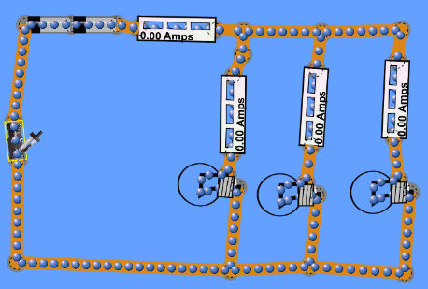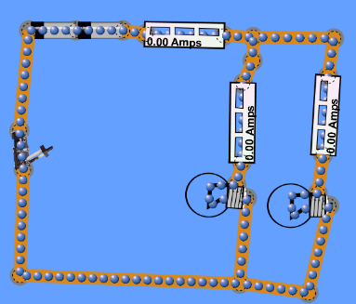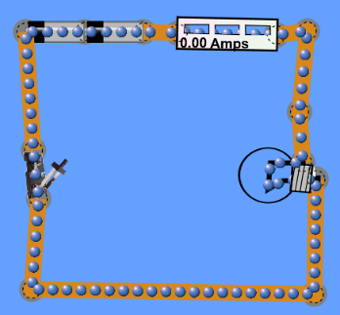

**Diagram:**

Click on the voltmeter tool and measure the voltages across each of the devices in the chart below. If there is an X in the chart, that means you can’t measure that parameter.

**Table 2: Parallel Circuit Analysis**

|  |  |  |  |  |  |  |  |  |  |
| --- | --- | --- | --- | --- | --- | --- | --- | --- | --- |
| Circuit | Total  Current in Main branch of Circuit (A) | Voltage  Across  Switch (V) | Voltage  Across  Batteries  (V) | Voltage  Across  Bulb 1  (V) | Current through bulb 1  (A) | Voltage across Bulb 2  (V) | Current  Through  Bulb 2  (A) | Voltage across Bulb 3  (V) | Current  Through  Bulb 3  (A) |
| 1. 1 bulb |  |  |  |  |  | X | X | X | X |
| 1. 2 Bulbs |  |  |  |  |  |  |  | X | X |
| 1. 3 Bulbs |  |  |  |  |  |  |  |  |  |

1. How did the brightness of the bulbs in circuits 2 and 3 compare with the bulb brightness in circuit 1 in this case?
2. Look at the total current values. What happens as you add parallel branches in the circuit.
3. What do you notice about the voltage readings in parallel branches?
4. The light bulbs in each circuit are the loads. Find the total current in all of the branches and compare the total current in the branches with the current in the main branch.

|  |  |  |
| --- | --- | --- |
| Circuit | Total Current in main  Branch (A) | Total Current in All branches (A)  *Show the current values you add up |
| 1 |  |  |
| 2 |  |  |
| 3 |  |  |

In each case, how did the total currents in the branches compare with the total current in the main branch?

1. In this parallel circuit we get much more total current than produced by the same batteries with a single series circuit. We know that you never get something for nothing in this world! What might happen to the batteries in a parallel circuit compared with the batteries to the series circuit?

**Summary Questions:**

1. What conclusions can you draw about voltages and current in a series circuit?
2. What conclusions can you draw about voltage and currents in parallel circuit?